PROBLEM STATEMENT :

In this rapidly developing environment, the breathing air is very much important to us. That much important air should be in a sufficient pure level, it must rich in the purity level. But ,nowadays the air concentration is becoming very harmful to us. By the harmful gases are merging into the atmospheric air, it’s not good? Right!. So we are emerging the solution for this environment.

Who has this problem? :

All living Oraganism suffer from serious disease relating to respiration and lungs.

Why should this problem be solved? :

To save human life and to control haxardous air pollution that is increasing day by day.

How will we know this problem has been solved? :

With the help of the monitoring air pollutants with real-time data, can take preventive measeres which gradually help in controlling the air pollution.

Background Information :

* The model is using the VGA Monitor interfacing with microcontroller for directly displaying the monitored data, also helps to replace bulky and costly displays.
* The increase in popullation and infrastructures alongside increases the pollution wgich can severly garm the living being and the environment.
* On daily news relating to increased air pollution and irs harmfull effect made a matter of concern for our research. The following references is also been used:
  + - * Daily NEWS
      * Prohest mentor experience
      * Internet

THE STEPS INVOLVING ARE AS FOLLOWS:

Step 1: WORKABLE SOLUTIONS

* This model requires microcontroller and gaseous sensors.
* The final project model will take a form of portable device for plug-n-play at any VGA display monitor.
* This device need to be mounted over vehicles for monitoring wide area and providing a real time data.

Step 2: THE PROTOTYPE

* Choose the best workable solution and create a plan to bulid a prototype.
* What materials will you use for your prototype?  
  The prototype be a model and also be further worked on to make more compact.

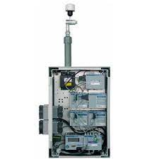**Air quality monitoring device**

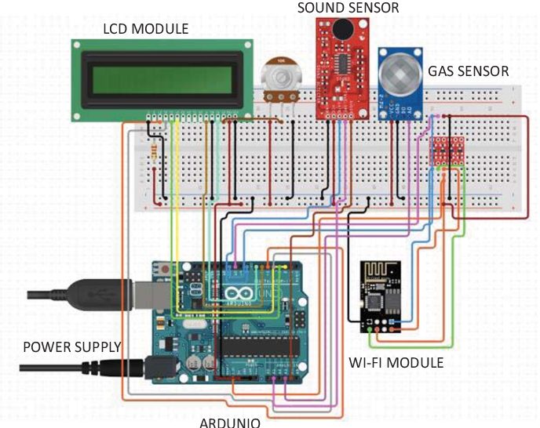

**AIR POLLUTION MONITORING**

Step 3: SENSORS DETAILS

|  |  |
| --- | --- |
| SENSOR | SPECIFICATION |
| DHT22 | TEMPERATURE , HUMIDITY |
| MQ-7 | CARBON MONOXIDE |
| MQ-135 | AIR QUALITY SENSOR |
| DS3231 | DATE AND TIME SENSOR |
| SDS021 | PARTICULATE MATTER |

Step 4: WORKING

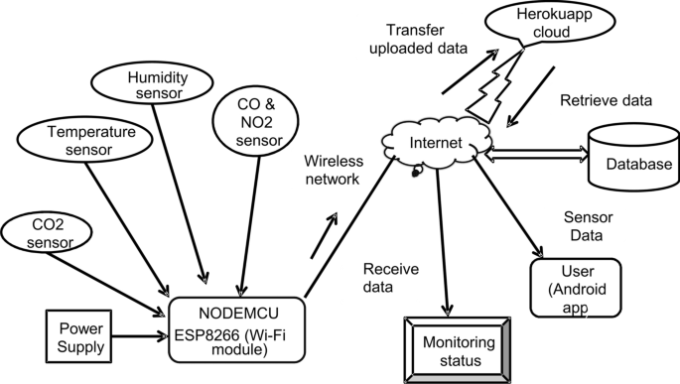

Step 5 : TESTING THE PROTOTYPE\

* What worked? What did not work ? why?
* What materials need to be changed and/or kept? Why?
* Did the size of your prototype five you enough information to move forward with a final product? Why or why not ?
* Did you have other people test your design and give you feedback? Why or why not?

Step 6: HOW?

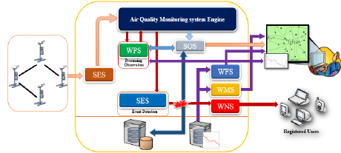

Step 7: HOW TO USE

Basically the data stored over cloud will be accessible to all as we are prociding a web sevice to them from which they can gather any information related to air pollutants in their vicinity.

Step 8: REDESIGNING THE PROTOTYPE

* Use the data from your testing to redesign with…
  + - Different materials
    - Different builds
    - Different sizes

FINAL RESULT :

The paper presents a detailed survey on the tools and techniques employed in existing smart water quality and air pollution monitoring systems. Also, a low cost, less complex water quality monitoring system is proposed. The implementation enables sensor to provide online data to consumers. The experimental setup can be improved by incorporating algorithms for anomaly detections in environment.

* This proposed Air and water quality early warning system is hoped to play a key role in future for its accuracy and effectiveness,
* This system mainly consists of two parts: prediction model and evaluation model.
* The results expecting that the proposed model has the best accuracy and stability compared to the other existing models

GITHUB LINK : https://github.com/Saravanankodi/Naan-mudhalvan-IOT-group-4-Team-6.

*SUBMITTED*

*BY*

*TEAM MEMBERS*

|  |
| --- |
| SARAVANAN.K(au821121104048) |
| MURUGANANTHAM.P(au821121104036) |
| MOHEMMED ASICK.A(au8211211032) |
| MANIBHARATHI.V.S(au821121104029) |
| GOVINDHAVASAN.K(au821121104301) |